1. PROGRAM

SUM OF TWO NUMBERS

#include<iostream>

using namespace std;

int main()

{

int x=5,y=5;

cout<<x+y;

}

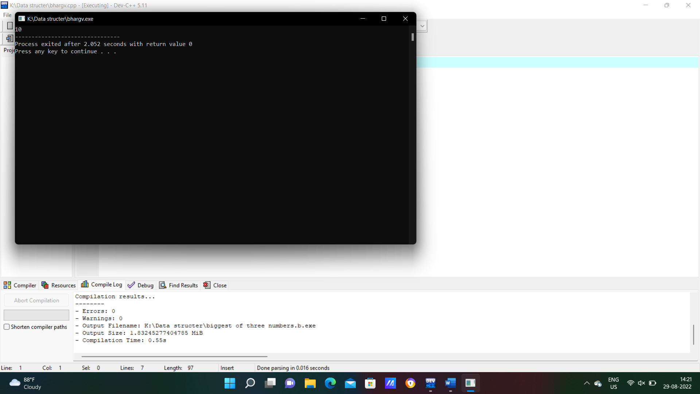

1. PROGRAM

SUM OF TWO NUMBERS

#include<iostream>

using namespace std;

int main()

{

int x=3.14,y=4.0;

cout<<x+y;

**3.PROGRAM**

**SUM OF TWO MUNBERS**

#include<iostream>

#include<conio.h>

using namespace std;

int main()

{

int x,y;

cout<<"enter x and y values";

cin>>x>>y;

cout<<"sum of two numbers"<<x+y;

}

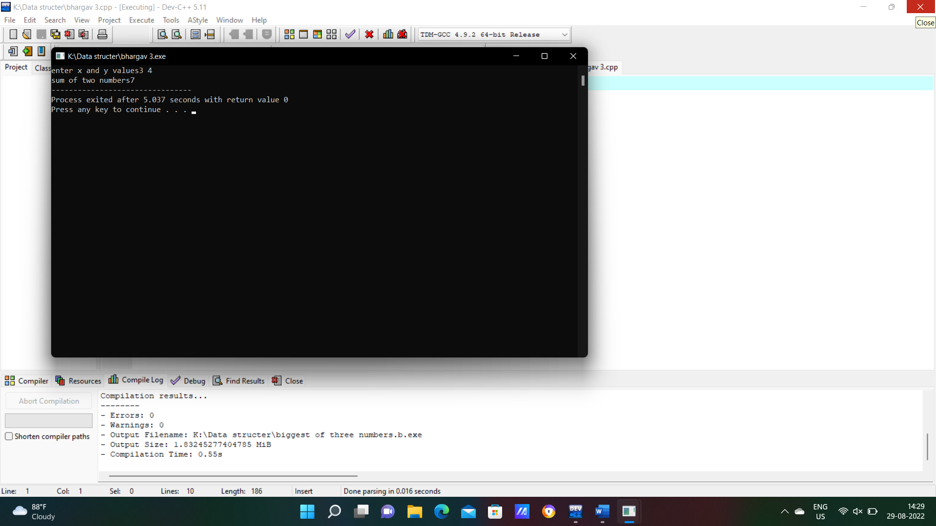

1. **PROGRAM**

**ELIGIBLE TO VOTE OF NOT**

**#include<iostream>**

**using namespace std;**

**int main()**

**{**

**int age;**

**cout<<"enter the age";**

**cin>>age;**

**if(age>0 &&int(age))**

**if(age>=18)**

**{**

**cout<<"eligible for vote";**

**}**

**else**

**{**

**cout<<"not eligible for vote";**

**}**

**

1. **PROGRAM**

**EVEN OR ODD**

#include<iostream>

using namespace std;

int main()

{

int num,odd,even;

cout<<"enter the number";

cin>>num;

if(int(num))

{

if(num%2==0)

{

cout<<"number is even";

}

else

{

cout<<"number is odd";

} }

else

{

cout<<"not accepted";

}

return 0;

}

1. **PROGRAM**

**AREA AND CIRCUMFERNCE OF CIRCLE**

#include<iostream>

using namespace std;

int main()

{

float r;

cout<<"enter radius";

cin>>r;

int exp;

cout<<"enter choice(1-2)";

cin>>exp;

switch(exp)

{

case 1:;

cout<<"area of circle"<<3.14*r*r;

break;

case 2:;

cout<<"circumference of circle"<<2*3.14*r;

break;

}

}

1. PROGRAM

BIGGEST OF THREE NUMBERS

**#include<iostream>**

**using namespace std;**

**int main()**

**{**

**int x,y,z;**

**cout<<"enter x,y and z";**

**cin>>x>>y>>z;**

**if(x>y && x>z)**

**{**

**cout<<"x is greatest";**

**}**

**else if(y>z && y>x)**

**{**

**cout<<"y is greatest";**

**}**

**else**

**{**

**cout<<"z is greatest";**

**}**

**}**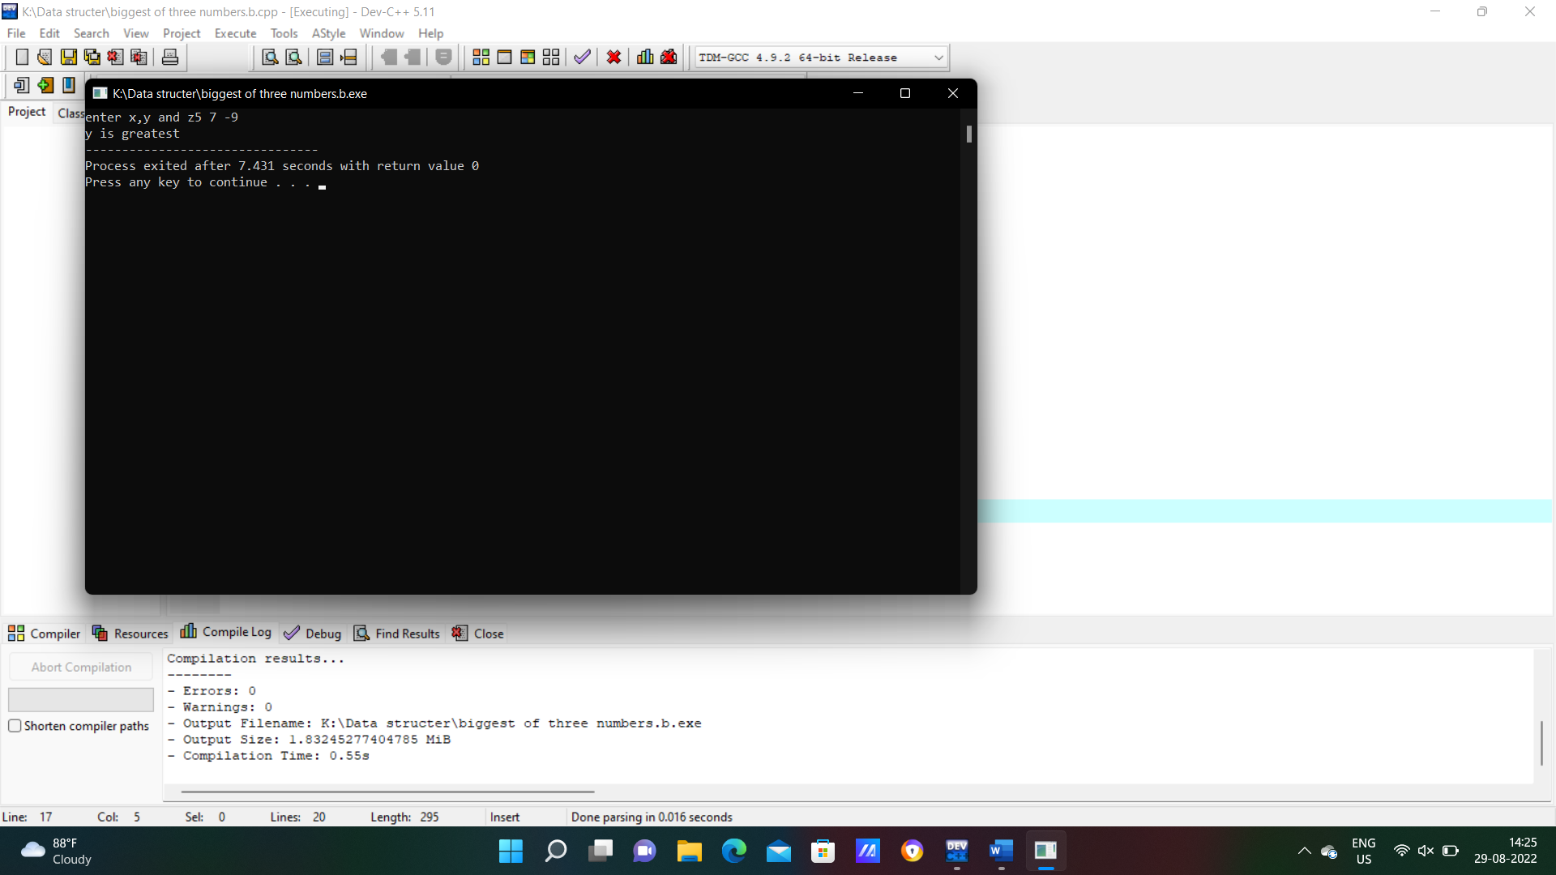

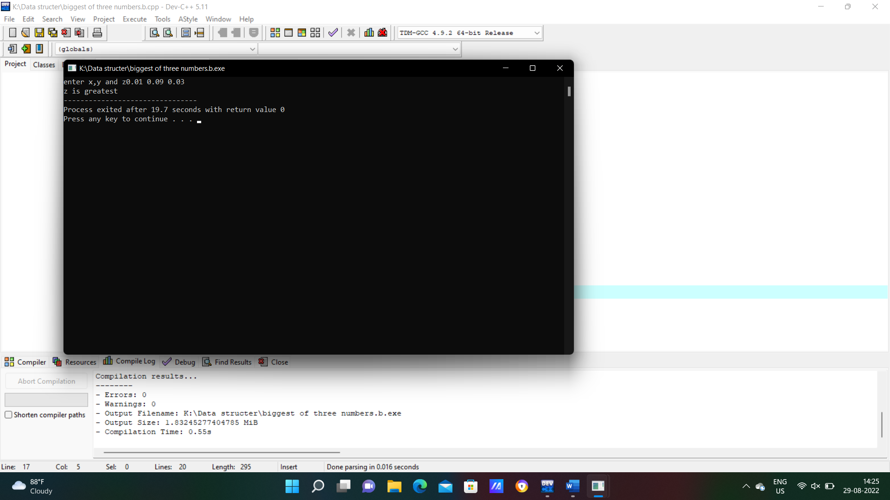

1. PROGRAM

SIMPLE AND COMPOUND INTEREST USING CLASS AND OBJECT

**#include<iostream>**

**#include<math.h>**

**using namespace std;**

**class interest**

**{**

**int p,t,r;**

**public:**

**int getdata();**

**int display();**

**};**

**int interest::getdata()**

**{**

**cout<<"enter the values of p,t,r";**

**cin>>p>>t>>r;**

**}**

**int interest::display()**

**{**

**cout<<"simple interest"<<p*t*r/100;**

**cout<<"compound interest"<<p*(1+r/100,t);**

**}**

**int main()**

**{**

**interest i;**

**i.getdata();**

**i.display();**

**}**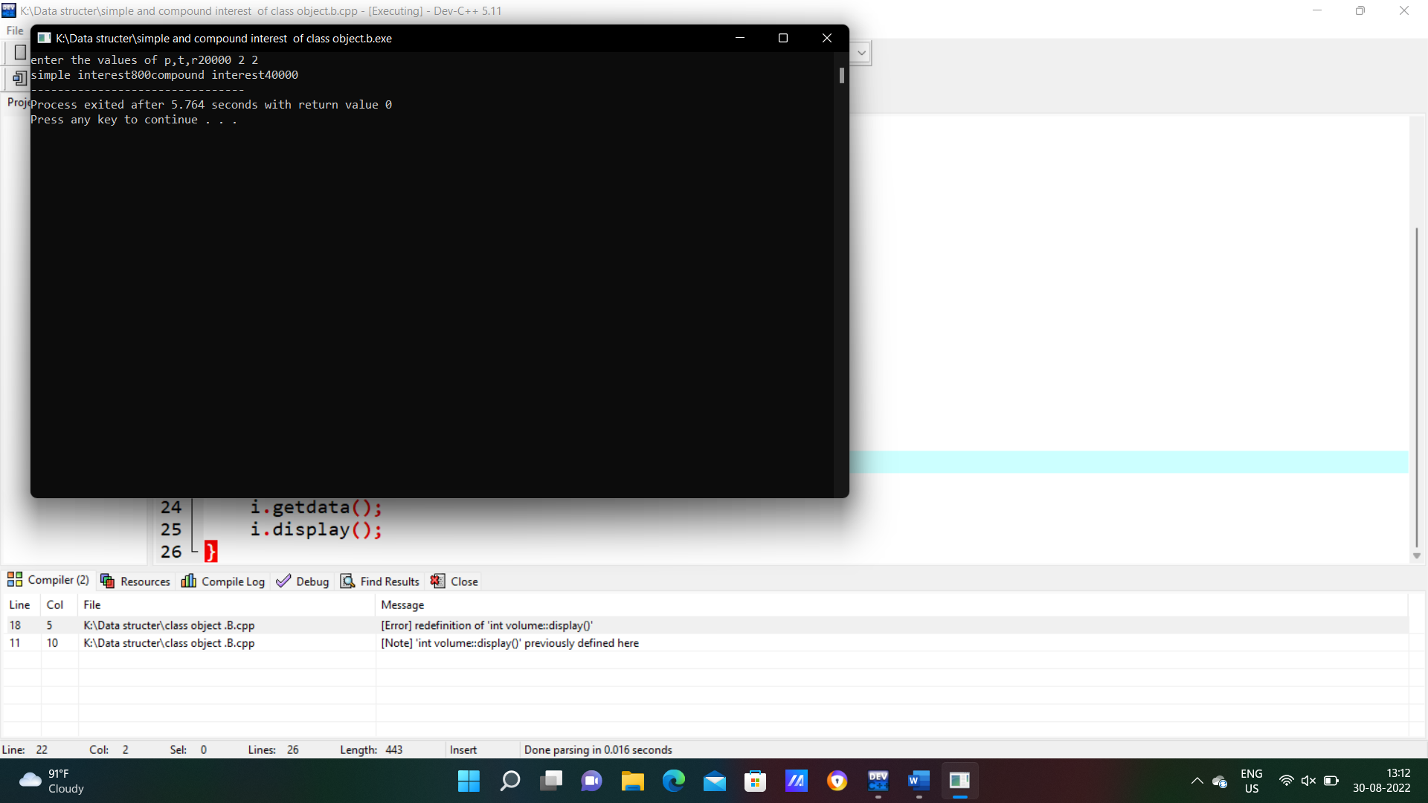

1. **PROGRAM**

**VOLUME OF CONE BY USING CLASS AND OBJECT**

**#include<iostream>**

**#include<math.h>**

**using namespace std;**

**class volume**

**{**

**float r,h,x;**

**public:**

**int getdata();**

**int display();**

**};**

**int volume::getdata()**

**{**

**cout<<"enter the radius";**

**cin>>r;**

**cout<<"enter the height";**

**cin>>h;**

**return 0;**

**}**

**int volume::display()**

**{**

**cout<<"volume of cone";**

**x=0.33*3.14*r*r*h;**

**cout<<x;**

**return 0;**

**}**

**int main()**

**{**

**volume x;**

**x.getdata();**

**x.display();**

**}**

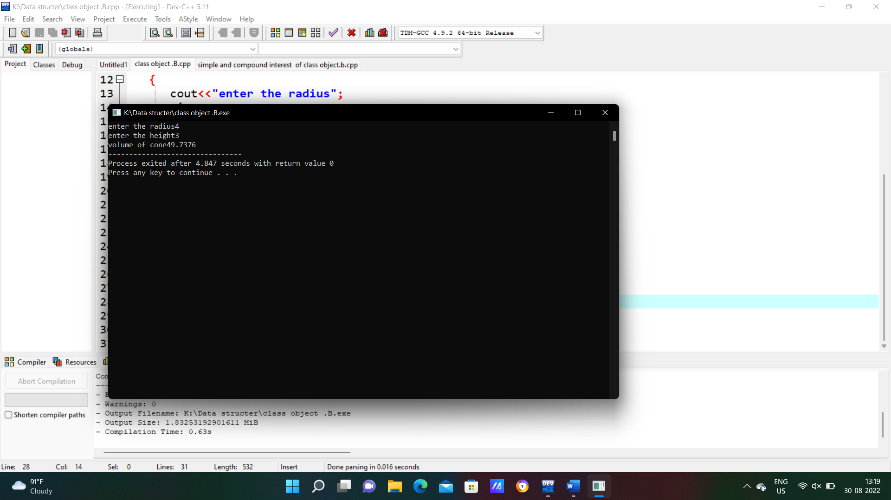

1. PROGRAM

BIGGEST OF THREE NUMBERS USING CLASS AND OBJECT

**#include<iostream>**

**using namespace std;**

**class big**

**{**

**int x,y,z;**

**public:**

**int getdata();**

**int display();**

**};**

**int big::getdata()**

**{**

**cout<<"enter the values of x,y,z";**

**cin>>x>>y>>z;**

**}**

**int big::display()**

**{**

**if(x>y&&x>z)**

**{**

**cout<<"x is biggest";**

**}**

**else if(y>z&&y>x)**

**{**

**cout<<"y is biggest";**

**}**

**else**

**{**

**cout<<"z is biggest";**

**}**

**}**

**int main()**

**{**

**big b;**

**b.getdata();**

**b.display();**

**}**

